Phytoremediation Projects

**ENDOPHYTE-ASSISTED PHYTOREMEDIATION OF TCE**

* Trichloroethylene (TCE) is one of the most widespread contaminants across the country
* Ph.D. graduate student, Jun Won Kang, isolated an endophyte of poplar that can rapidly and aerobically degrade TCE.
* The mechanism is unknown. PCR amplification of known genes (i.e. MMO) was negative. Unlike other aerobic TCE-degraders, strain PDN3 did not require any inducing phenolics, making it a better strain for bioremediation practices
* We are testing if inoculating plants with PDN3 will improve phytoremediation of this important pollutant
* Khan, Z and Doty, S.L. 2011. Endophyte-assisted phytoremediation, *Current Topics in Plant Biology*, Vol. 12, 97-105.
* Kang, J. W., Khan, Z., and Doty, S. L. Biodegradation of TCE by an endophyte of hybrid poplar. *Applied and Environmental Microbiology* 78(9):3504-3507.

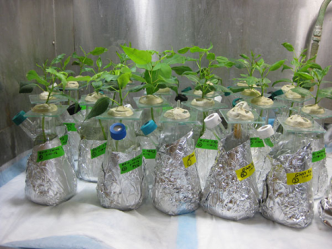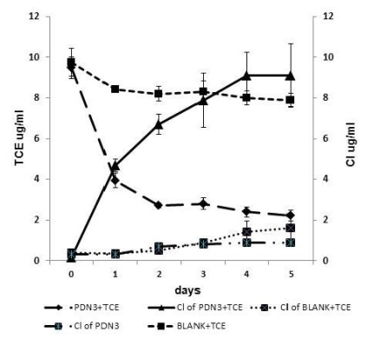

**ENDOPHYTE-ASSISTED PHYTOREMEDIATION OF PAH’S**

* Polycyclic aromatic hydrocarbons (PAHs) are persistent environmental contaminants
* Research Scientist Dr. Zareen Khan, identified naturally-occurring endophytes of poplar and willow that can grow on PAHs as a carbon source. The best performing isolate, PD1, was identified as a *Pseudomonas putida.* The mechanism of PAH degradation is unknown.
* Undergraduate researcher, David Roman, demonstrated that inoculation of willow plants with the best PAH-degrader reduced the phytotoxic effects of the PAH, phenanthrene.
* 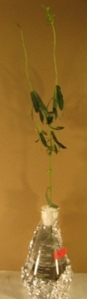Project status: Experiments need to be done to quantify the removal of phenanthrene by the colonized plants, and to verify colonization.

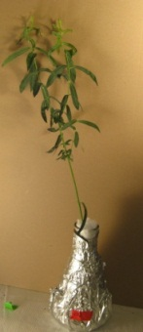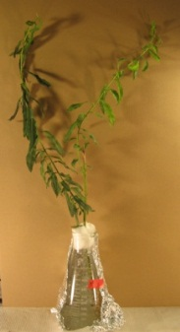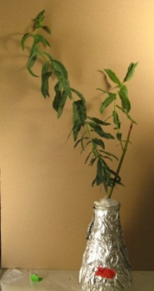

**Inoculated with PD1**

Day 1 Day 19

**Uninoculated control**

Day 1 Day 19

Day 1 Day 19 Day 1 Day 19

INOCULATED WITH PD1 UNINOCULATED CONTROL